Enter subject info:

participant: Study ID [eg. SamH]

order: Condition_1_HT/ 1_TH/ 2_HT/ 2_TH

block: all/ health/ taste/ choice

h_list: foodlist 1/2/3/4/5/6 [To test, use ‘Test/1/2’]

t_list: foodlist 1/2/3/4/5/6 [To test, use ‘Test/1/2’]

c_list: foodlist 1/2/3/4/5/6 [To test, use ‘Test/1/2’]

time point (enter number only): number of the time point [eg. 1]

excluded reference food: food(s) excluded as the reference food [eg. eggs, trail mix]

backup reference food: saltines/ other

if “other”, please speficy: backup reference food if not saltines [eg. Pretzels]

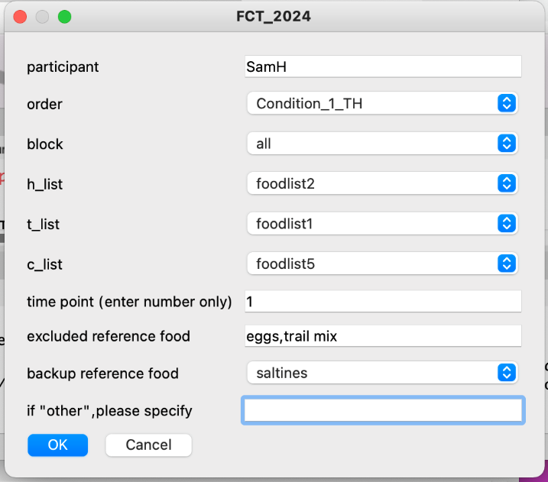

Changes made in this version:

Updated in April, 2024:

1. Modularity

* be able to start the task from a single block
  + “all”: program would perform all three blocks
  + “health”/“taste”: program will only perform H or T rating task.
  + “choice”: program will only perform Choice rating task.
    - For the case where experimenters choose a backup reference food, the program will proceed without the H/T rating data.
* If there is an existing data file ending with _all.csv for this participant at this timepoint, the new output file will overwrite the original file (with existing data), so that there will only be one _all.csv file for each participant at each time point in the data folder.
* Before running the modularity operation (choosing “health”, “taste”, or “choice” individually), make sure that **only one file (or no files)** is named ***“[participant id]_[time point]_xxx_all.csv”*** is present in the data folder for that participant. Eg. “*SamH_T1_2024-06-27_11h26.15.823_all*”

1. Saved data to a .csv file after each trial

* the following files will be saved in the program:
  + behav.log -> save automatically after each action
  + all.csv -> save after each food rating/choice, will overwrite the original all.csv file after each rating, so **DO NOT OPEN** this data file while running the program
  + choiceoutput.txt -> save at the end of the choice block, with a list of potential snacks
  + health.csv -> save at the end of the program with health rating data only
  + taste.csv -> save at the end of the program with taste rating data only
  + choice.csv -> save at the end of the program with choice data only
  + foodtask.txt -> save at the end of the program with data from health.csv, taste.csv, choice.csv

1. Reduced the likelihood of accidental termination

* To exit the program during instructions, **press “Escape” and then “Return”** (or “Enter”, same key)
* The program won’t terminate in the middle of a rating block unless the following events occur:
  + Attempt to edit the python scripts
  + Attempt to open/edit the data files
  + Computer shuts down or Psychopy program terminates accidentally
  + Other unforeseen reasons in the MRI control room (could be a disconnection using the cord, etc.)

1. Added a text box to exclude previously used reference food

* Text box can be left blank
* Can enter multiple food items in the box, but food should be **separated by a comma (,)**
* Entries are case sensitive and should match the food name exactly (food names are listed below) *(same for reference food entries)*
* ["m_and_m", "yogurt pretzels", "mozarella sticks", "yogurt no spoon", "corn cob", "1%milk", "reeses", "kiwi", "orange slices", "baby cheese", "Tribe humus pita", "rigatoni and sauce", "Cheese nachos", "bagel plain", "burger", "air popcorn", "string cheese", "celery and carrot sticks", "raisin bran w milk", "seaweed", "green beans", "sushi w_condiments", "baguette oil", "grilled cheese", "eggs", "Hershey Kisses", "apple slices", "rigatoni", "hotdog w must", "grilled chicken strips", "trail mix", "mini muffins", "Pretzels", "fried eggs", "granola w milk", "chicken nuggets2", "broccoli cauliflower", "soy chips", "pickles", "lollipops", "froot loops w milk", "cucumber slices", "banana", "bagel and cc", "PB", "peaches", "ice cream sundae 002", "Skim milk", "Grapes", "cupcakes am", "soup with spoon", "salad w chicken", "mac & cheese", "saltines", "doughnuts", "Whole milk", "mushrooms", "pizza", "steak", "yellow popcorn", "cherry tomato", "mashed potato", "raisins", "turkey sandwich", "strawberries", "french fries", "rice cakes", "baked potato", "cherries", "american cheese", "tacos", "ritz", "cookies", "sour patch", "avocado", "brownie"]

1. Added a dropdown list for selecting a backup reference food

* Added “saltines” and “other” for experimenters to add other backup reference foods
  + backup reference food need to be in the H/T food rating list
  + backup reference food should be assigned at the beginning of the task
  + the default backup reference food is **saltines**

1. Added a text box to enter other back-up reference food if no food qualified for ref food and default foods are excluded

* “if “other”, please speficy” box should be left blank if a backup reference food was selected. This entry will be prioritized over the selected back-up reference food in the drop down menu
* Can only enter one food item as the backup reference food; entry is case sensitive and should match the food name exactly (see No.4)
* If accidentally put the same food as excluded and back-up reference food, and no other food is qualified to be the reference food, then back-up would become the reference food

Updated in June 2024:

1. The “time point” field was changed from a drop-down menu to a text box.

* Experimenters should **ONLY ENTER NUMBERS** (without spaces or punctuation) in the “time point” box.
* To ensure modularity, please make sure to enter the **SAME VALUE** in the “time point” box when running modules separately for the same participant at the same time point.

Major changes for data pulling:

* The sum data file will be saved in _all.csv, instead of being saved in the _behav.csv file
* Time point variable is added to the _all.csv file and added to the name of all saved files, eg. “TEST_T1_{date and time of the study}_all.csv”

Other Notes:

* When running the program in Psychopy, make sure you only press the green “run” button once, and there’s only one window to enter participant’s info. If multiple windows appear, there might be an issue when saving the data.

* The MRI version has a longer wait period before the task starts, and well the fixation time is also longer.